
PSHE Newsletter
Term: Autumn 1 2026 (Personal, Social and Health Education)

Relationships Education/ Relationships and Sex Education, new statutory Guidence update and focus group
As you may be aware, the government have issued new statutory guidence for Relationships Health and Sex Education in schools, (RSHE) which schools needed to have in place by September 2026. At Castle School, we go over and above the statutory guidence and are therefore already teaching most of the new guidence. Updated planning is now being used across the school. New guidence that we have always taught, includes, for example using anatomically correct body parts across the school, travel safety and accessing healthcare services, information for these lesssons are included in these newsletters. There are lots of important additions that are now included in our planning, and are being used, that weren’t as prevelant when the 2020 guidence was published, for example more information aboout vaping, AI and a greater focus on online risks, as technology develops. We will continue to plan and teach lessons that are appropriate to each pupils age and understanding, ensuring that everyone has access to a robust PSHE curriculum that sets them up for life. Please do ask Hayley, if you have any questions about the new curriculum. We are excited about the changes that ensure our curriculum remains relavent to life today.
The Castle School were part of the focus group, providing feedback to the PSHE association, on their updated SEND planning framework, which was very exciting! The new framework is even better than the last one for our pupils, with an extra column to break up the steps further, for our learners with severe and complex needs, and lots more up to date information for all our learners, with greater focus on areas mentioned above. The planning, as recomemented by us, now inlcudes Key Stage 5 too. While not statutory for KS5, PSHE remains vitally important for our Post 16 pupils, and they continue to have a rich PSHE eduction at Castle. We have worked very hard, behind the scenes, and all planning was ready use, at the start of this term. As you can see, pupils have already been doing some fabulous learning, using the new planning. Students following the Adventure pathway, will continue with their PSE planning, and KS2-5 are now following the new, updated PSHE planning, which was introduced ready for September. We are proud of the updated planning and know that this ensure all pupils receive a robust and up to date PSHE curriculum, as Castle.
Celebrations of our learning this term: | Some photos of our learning
At the Castle School, we work really hard in PSHE, and have some celebrations to share with you:  Students across the school have been getting to know each other and have been learning new routines and preferences, (some of us love dancing!)  Post-16 School Council reps, along with other interested students, had a fabulous visit to Newbury Town Hall. They had a tour of the Town Hall, found out about what the Mayor of Newbury and councillors do, learnt about what democracy is and how it works, learnt a bit about the history of Newbury and tried on the councillors' robes! It was a really informative visit led by the mayor herself!  Everyone showed an interest in what they were being told and were incredibly respectful. We are very proud of them  Emily Craggs, Post 16 lead, said it was an honour to be part of the visit.  We are very excited to tell you that the Post 16 WOW team are continuing to make great progress with the work for the Sensory Garden at Love Lane! Thank you to the site team for ordering the paint and compost, (and then more paint this term!) and for all their hard work with raising the beds and securing the fences and the structures.  The fabulous WOW students from post-16, have come each week, all term for internal work experience at our Love Lane site. The students are working hard making the School Council's dream of a sensory garden a reality. They have got to work, weeding the raised beds, cleaning, sanding and painting. The area has been swept, weeds have been removed, the chairs, planters and table have been sanded, and painting is now complete, after extra paint was ordered. Students have been doing an amazing job transporting soil into the planters. The group demonstrated good communication skills and great teamwork. We are looking forward to seeing the finished garden very soon. The group have painted the raised beds, tables and chairs and pergola, in the very colourful shades that the school council picked! The garden is now looking very colourful, and we are very excited! The WOW group are going to go shopping, with Martin, our green fingered caretaker, to buy some sensory plants for the garde, thanks Martin. Thank you Post 16 WOW students; you are doing us proud! Thanks to the School Council for being determined to make the sensory garden an inviting learning space for all students again. We are proud that they particularly wanted to get it right for their peers who use wheelchairs, ensuring the beds were raised to a suitable height (by our fab site team, and that the plants chosen Thank you Friends of Castle for funding this brilliant project, that will benefit our whole school community. Thank you to Emma Williams and Emily Craggs and other Post 16 staff for all their hard work with this project.  Lots of students have now had their flu imms. York class did an amazing job of getting used to what the flu spray would feel like, with practice, model sprays. As you can see, they did a so well, and York team are very proud of them.  Staff are continuing to good use, their training on how to use the Chailey Heritage RSHE programme, which is designed to support our learners with severe and profound learning difficulties, to be able to access RSHE (Relationships, Sex and Health Education,) using sensory stories, props, and anatomically correct dolls. Lots of classes are using the dolls to support their understanding of RSHE. Windsor class have been using the dolls to learn about the importance of wearing deodorant, with the help of the dolls and a t-shirt with smelly raw onion armpits! Well done, Windsor.  In the new PSHE curriculum, there is a greater emphasis on first aid. Pembroke and Powis have been working very hard helping their poorly patients! | 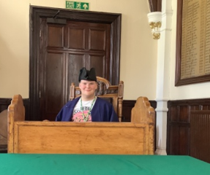  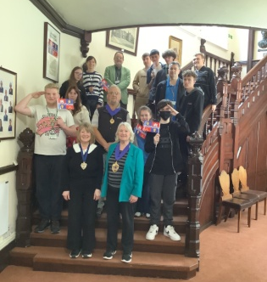  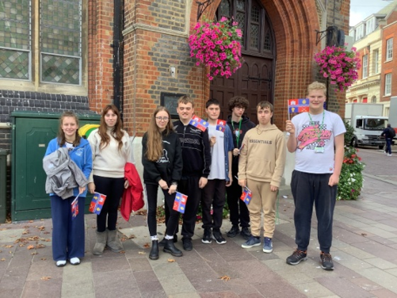  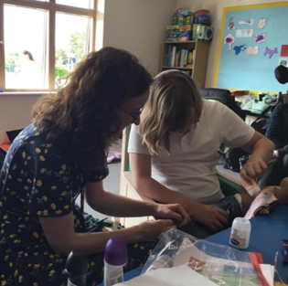  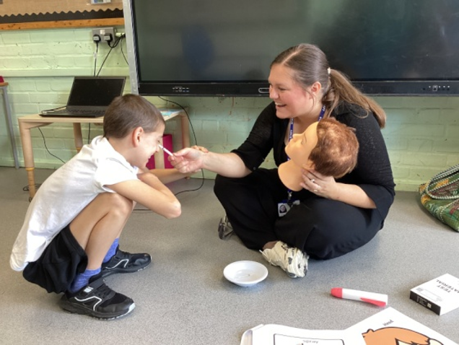  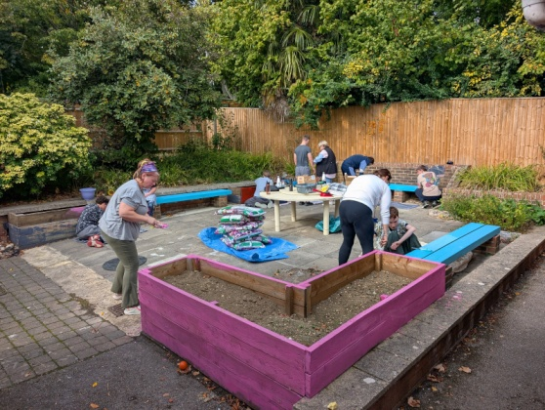  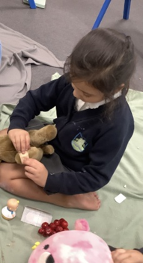  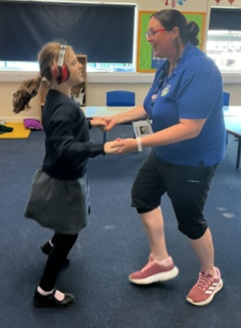
Just a reminder that everyone with an EHCP, age 14 plus, is eligible for an annual health check.
Here is some information from Dr Heather Howells, who is the GP Clinical Lead for Mental Health and Learning Disabilities, for Berkshire West:
You may be aware that from the age of 14, everyone in a special needs school, is eligible for an Annual Health Check at their GP surgery. All people with a Learning Disability aged 14 and over should receive a check every year. The Annual Health check covers all aspects of health and wellbeing, you can learn more about Annual Health Checks here:
https://www.mencap.org.uk/advice-and-support/health/annual-health-checks
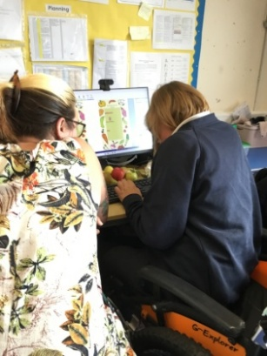
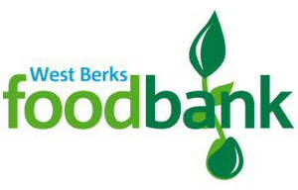
Food bank donations
Thank you so much for all the food bank donations so far. They will be gratefully received by West Berks food bank, when Stuart Team School council representatives deliver the donations on the 7^{th of} November. If you find any extra donations, when clearing out cupboards over half term, please do still give them to your class teacher, before the 7th of November. Just a reminder, the food bank are in particular need of:
Tinned veg, pasta sauce, UHT Milk, Coffee, Cereal, Tinned Tomatoes, sugar, sponge puddings, toilet roll and shower gel.
A school council representative has also made a visual list of this, to support our pupils with what they can bring in. Thank you for your support!
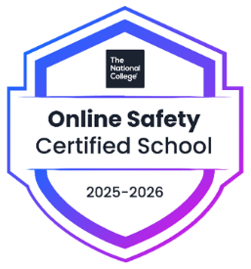
We are proud to say that the Castle School is an Online Safety Certified School again for 2025- 26
You can see our certificate in reception, along with some internet safety guides, which you can also download from the National College, or pick up from the display in the pastoral room. There are also some guides on our school website, in We have National College logins for all staff, so that everyone can help keep our pupils safe. All teachers, TAs and safeguarding leads completed their annual certificate for online safety again, at the start of the academic year, so that we can help keep our pupils safe online, and will complete this again in the Autumn term. Many staff continue to access other courses and seminars. Teachers are able to use the resources and planning to ensure that we are giving our students relevant and up to date online safety lessons, throughout the year. Lots of these resources are included in the updated PSHE planning documents.
Some parents and carers have signed up and have completed courses and accessed important internet safety guides for their child. We are hoping that more parents will sign up. If you would like to sign up to help your child stay safe online, please do. We have put some useful courses in the watch list, once you log on.
We are sure that you will agree that online safety is so important to keep everyone safe, which is why we are committed to training our staff and giving our pupils the best possible lessons and care. We are looking forward to more parents joining us with our National Online safety journey. Teachers, Tas and leadership have all had their annual, online safety training and are using the resources to teach pupils.
If you would like a parent login, for National Online safety, (now called Wake up Wednesdays) to make use of the brilliant training and resources, please contact Hayley.
Hodonnell@castle.w-berks.sch.uk
Teachers, TA’s and all our DSLs have completed online safety training, already this year. We also have essential online safety guides up in the staff room, for all staff to access.

