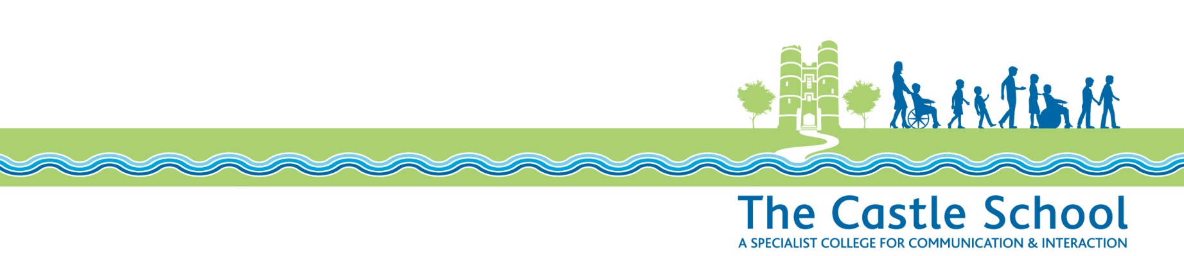

Internet Access Policy

At The Castle School the purpose of Internet access is to raise educational standards, to support the professional work of staff and to enhance the school’s management information systems. Also to prepare students for life after they leave the school.

The Internet will:
- provide access to worldwide educational resources;
- provide access to information on government initiatives
- provide opportunities for information and cultural exchanges between students world-wide
- provide up-to-the minute news and current events
- encourage cultural, social and leisure use in libraries, clubs and at home
- allow discussion with experts in many fields
- facilitate staff professional development by giving access to educational materials and good curriculum practice
- allow communication with the advisory and support services, professional associations and colleagues
- allow exchange of curriculum and administrative data with local authorities and DfE

The school recognises that it is difficult to remove completely the risk that pupils might access unsuitable materials, but it uses a filtered access Internet Service Provider (ISP). The ISP will be contracted to West Berkshire Council and subject to the next paragraph, all Internet services will be provided through the West Berkshire WAN (to provide security, restrict access to appropriate material and a “firewall”).

In certain situations, e.g. older students, exposure to the Internet other than through the WAN (e.g. BT/AOL) is needed to familiarize them with the type of access they will experience out-of-school. Where this happens parents of these students will be given a copy of the appropriate policy and asked to sign a consent form.

The school’s web site will promote the school, inform parents and carers and enable pupils to celebrate and publish work for a wide audience.

Rights Respecting School
This policy adheres to the principles of the United Nations Convention of the Rights of the Child (UNCRC) specifically articles: 1, 2, 3, 4, 5, 12, 14, 15, 16, 17, 18, 19, 23, 28, 29, 31, 34, 36 & 42.
Last review: Summer 2026
Next review date: Summer 2029

