

The Castle School Behaviour Policy

DOCUMENT HISTORY

Written By | Caroline Whitlock and Megan Beckingham Summer 2024
Date Approved | Reviewed Summer 2026
Approved By | Full Governing Board
Review Due | Summer 2027

Related Documents:
The Castle School Safeguarding and Child Protection Handbook
Keeping Children Safe In Education
The Castle School Code of Conduct
SEND Policy
Anti-Bullying Policy
Suspension and Exclusion Policy
Restrictive Intervention Policy

Purpose of this policy
The purpose of his policy is to provide the foundations and framework of our whole school, person-centred approach. It is the policy of this school to enhance a student's self-awareness, self-esteem and respect for others and their environment, both within the school and the wider community. Through this shared belief, the school aims to promote meaningful and effective person-centred learning in a positive and friendly atmosphere.
Our behaviour policy is aimed at improving outcomes for all students by promoting and supporting their engagement with education and the community. We adopt an inclusive approach, by understanding that behaviour is communication of need or unspoken processing. We engage in processes of review and adaptation of support to meet the needs of the student.
Our policy is underpinned by therapeutic, person-centred approaches which prioritise the relational needs of everyone, in order to create positive experiences from which young people learn and grow. How adults interact, communicate and respond to students in all situations impacts the experience and subsequent learning from it.
All staff understand and recognise that positive emotional well-being leads to higher levels of emotional engagement, regulated behaviour and progress in learning and personal development. In creating an inclusive culture, we embed therapeutic practice which includes the PROACT-SCIPr-UK approach. This policy incorporates these principles and guides all staff to support behaviour and engagement by building relationships, creating a safe environment and meeting the individual needs of each student.

Aims of the policy
- To create an environment in which students and staff feel safe and where students feel empowered to believe in themselves and strive to be the best they can be.
- To ensure that everyone understands the role they have in creating calm, safe and successful environments and know who will support teams proactively.
- To be fully inclusive through an equity model of provision.
- To ensure that all children and young people are supported as individuals and that engagement and interactions are led by the individual needs of the student.
- To develop students’ regulation skills in ways that are not dependent on external rewards and to develop an understanding that behaviour is their own responsibility.
- Build the confidence and empower all staff through effective leadership and regular training.
- To secure a clear understanding, consistency and confidence in the procedures for communicating and supporting behaviours causing concern.
- To embed an approach that facilitates regulated behaviours through positive role models, clear and consistent structures, encouragement and recognition.
- To ensure there is a culture within The Castle School that values all students; allowing them to feel a sense of belonging, where they are able to seek emotional and well-being support.
- To have a whole-school approach to promoting good mental health.
Policy Principles
Equity and Equality. Equality is treating everybody the same. Equality aims to promote fairness, but it can only work if everyone starts from the same place and needs the same help. Equity is giving everyone what they need to achieve success.
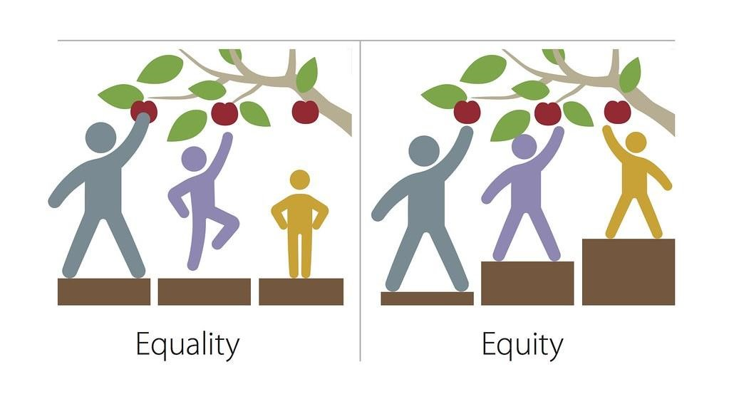
External discipline is controlling behaviour …Internal discipline is teaching behaviour.
To create positive and sustained change, we need to be curious and understand behaviour as a form of communication, not simply suppress or control it. For anyone to fulfil their potential, they must feel safe, intrinsically motivated and engaged. We all need different things to help us regulate, succeed and consequently behave in a way that facilitates a high quality of life.

Developing emotional regulation and engagement
At The Castle School, we have high expectations and aspirations for individuals’ behaviour, which is underpinned by prioritising the experiences and feelings of students. Co-regulation, leading to self-regulation, is developed by staff providing nurturing, responsive and consistent teaching and support.
Nurture – we teach that relationships and interactions should feel safe, comforting and enjoyable. In practice, this includes investing in relationships from the start; taking an interest and learning about their aspirations; likes/ dislikes; previous experiences; diagnosis and needs; medication and side effects; skills; culture; people and things that are important to them; developmental level and any other information important to that student.
Responsiveness – we teach that students’ needs and choices matter. In practice, this includes: ensuring expectations are appropriate and achievable; implementing
individual proactive/ active/ reactive support strategies; responding to all communication; empowering decision making through controlled choice and making adaptations to meet the needs of the student and others.
Consistency – we teach students that others can be trusted, are predictable and can be depended upon to set considered boundaries. In practice, this includes: establishing routines and timetables, using agreed scripted language/ responses, modelling, embedding forms of communication and person-centred strategies.
Central to developing emotional regulation and engagement is adopting a relational way of thinking, feeling, behaving and communicating. We understand that if a student feels emotionally connected and safe, they are less likely to communicate through behaviours causing concern. We aim to be nurturing, responsive and consistent through PACE-ful interactions.
The PACE Approach - PACE stands for Playfulness, Acceptance, Curiosity, and Empathy. It’s not just an intervention; it’s a way of being that fosters secure attachments between adults and children. Developed by Kim S. Golding and Daniel A. Hughes, PACE aims to make children feel safe and supported.
The four pillars of PACE are:

Playfulness: Read a child’s body language and find ways to connect. It doesn’t have to be related to education, it can be something perceived as low threat.
Acceptance: Accept children as they are, without judgment. Show them that you value and appreciate their uniqueness. Acceptance of their view point even when it differs from our own (that doesn’t mean we agree).
Curiosity: Be curious about their experiences, feelings, and thoughts. Ask openended questions to understand them better.
Empathy: Understand their emotions and respond empathetically. Show genuine care and concern. The PACE Approach improves relationships as it helps us understand children more deeply.
Slowing Down: By being playful, accepting, curious, and empathetic, we create a safe environment for children to thrive.

Restorative Practice
Our aim is to support reflection and regulation, connecting before correcting. We follow up the behaviour, its impact and consequences at the appropriate time, after regulation has taken place and support students to understand strategies for further occurrences. Restorative approaches refer to a range of methods and strategies which can be used both to prevent relationship-damaging incidents from happening and to resolve them if they do happen.
Inspired by the philosophy and practices of Restorative Justice, we aim to repair any harm caused to relationships and communities by conflict. Crucially, it is believed, that is best achieved by focusing upon the harm caused rather than assigning blame and dispensing punishment, which often fails to address the needs of those most affected. Students are supported to repair and restore following incidents by use of short scripted discussions in the moment, more structured discussions with key adults and in some instances prolonged pieces of work that would be incorporated into a student’s support plan. In all cases, restorative practice will be focused upon the needs of all individuals concerns, ensuring that communication needs and developmental stages are considered.
Understanding behaviour
Behaviour is communication and expression of need.
We understand that all behaviour is communication and to support students, we must remain curious and seek to explore the message behind it. This will help us consider the function and role the behaviour fulfils, highlight any unmet need and provide a starting point to expand the students’ means of communicating. For many students, the ways of working outlined within this policy forms the basis of their provision. A Therapeutic Plan may also be used to formalise a personalised plan to meet individual needs, aid consistency, reduce risk to self/ others and support engagement.
Our role is to help unpick the communicative function behind a behaviour as student experience different levels of emotional regulation, rather than moralise it. It must be understood that these experiences are highly individual and are responded to as such.
Within an emotionally regulated ‘Window of Tolerance’ – students are feeling calm, safe, able to engage.
Outside of this window of tolerance, students are starting to feel anxious and may be unsettled. They might be unable to engage, be withdrawn, starting to feel less safe or insecure, with mild to moderate feelings of not coping or overwhelm.
When emotionally dysregulated, students may present in crisis, panic, overwhelm, flight/fight/freeze/fawn response, shut down or unsafe.
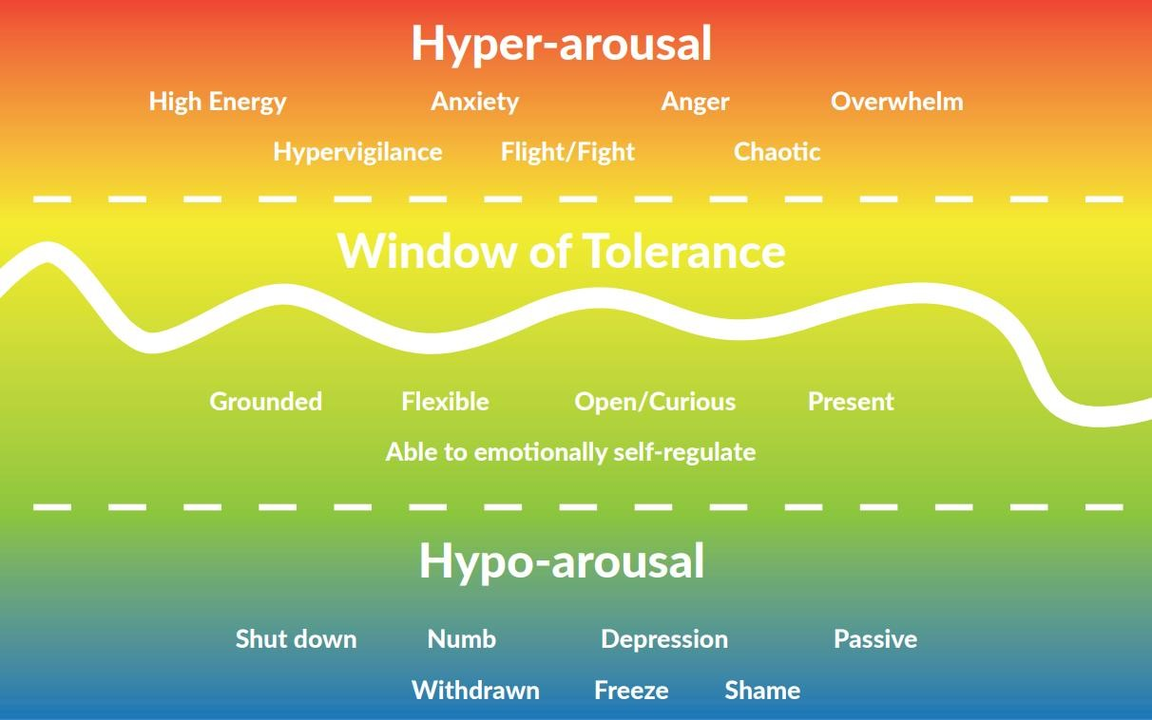

Levels of emotional regulation, functions of behaviour and strategies for support are unique to each individual. Below are examples of language to describe levels of regulation, functions (SEAT model) and possible strategies to support:

Regulated, safe, connected, engaged, within ‘window of tolerance’  X may communicate they are feeling regulated by:  - Initiating interactions with familiar people, smiling and engaging in playful exchanges  - Relaxed shoulders and body tension  - Engaged in a task for up to 15 minutes  - Reduction of movement e.g. jumping/ pacing to meet sensory needs | Proactive strategies to support  - Time embedded within the day to check in using visual tools  - Sensory diet is established, including x2 per day sensory circuits, movement  breaks and communication board with sensory items/ activities  - Learning to always be small chunked, with sensory breaks interwoven every 10/ 15 minutes  - Management of the environment – avoiding extended periods of loud/ busy spaces without option to seek alternative
Anxious, beginning to feel unsafe, disengaged, cautious, selfprotective, withdrawn, unsettled, mild to moderate feelings of not coping or overwhelm  X may communicate they are beginning to experience heightened emotion by: | Active strategies to support  - Subtly offer whiteboard as an alternative means of communication  - Consider adapting the demands being placed – both explicit and non-direct. Increase scaffolding to support e.g. adult writing response/ questioning  - Sit alongside X, maintaining connection and acceptance
- Subtly withdrawing from interactions  e.g. putting hood up, moving chair away from group  - Increased tension in body, especially raised shoulders  - Flushed cheeks  - Increase in speed/ intensity of repetitive movement, applying deep pressure on head by squeezing  - Reluctance to be in busy environments/ slower transitions  - Delay/ difficulty starting activities e.g.  problems with equipment, shares ‘work is boring/ too easy’ | - Be playful if appropriate, this can support X’s interaction  - Be curious – X responds to safe adults’ ‘wondering’ e.g. ‘I’m wondering if your chair has moved maybe because you’re  feeling a little worried about…’  - Offer sensory input (see sensory diet)  - Offer a change of environment e.g. time in sensory room/ quiet room
Dysregulated, overwhelm,  panic, crisis, flight/ fight/ freeze/ collapse, shut down, unsafe  X may communicate they are feeling very distressed and unsafe by:  - Screaming/ shouting, often with head in hands  - Dropping to the floor in curled position  - Running to enclosed areas e.g. toilet  - Hitting head with hands or on objects  - Negative self-directed talk | Reactive strategies to support  - Use photograph visuals and decreased verbal communication to offer a change of environment e.g. sensory room/ quiet room  - Minimise other people within the environment e.g. asking other students to give space  - Make proprioceptive items available e.g. sensory sock, weighted mat  - Maintain connection by staying close, accepting and reassuring that you are there  - Sometimes it helps to sit on the floor by X and hold out your hands (open, palm up). X will then hold your hands/ likes squeezes
Recovery, repair, restoration  X may communicate they are feeling safer and more regulated by:  - Approaching safe people, often  crying/ still upset  - Communicating they are hot, feel sick or feel hungry  - Asking repeating questions/ statements to seek reassurance e.g. ‘I am going home at 3’  - Accepting suggestions to support regulation e.g walk around track | Restorative strategies to support  - Offer a change of environment e.g. sensory room/ quiet room  - Ask if X would like a drink (tea), snack, jumper off etc. to support regulation  - Listen and respond to questions/ statements. It can help to write responses on a whiteboard  - Using choice board, consider options to support further regulation e.g.  playdough, walk around track etc.  When regulated, X finds comic strips helpful to explore their period of heightened emotion.

Flow Chart of Actions

The Flow Chart is the guide for staff to follow. It starts with the needs of all students in terms of supporting and reinforcing prosocial behaviour and then stages to follow when a student presents unsocial or antisocial behaviour.
This flow chart supports all staff and ensures that a holistic therapeutic approach is followed.

SEE APPENDIX
Scripted Language
Scripted language is a communication strategy which can support students to regulate and manage their stress responses.
Scripted language encourages nurturing and emotionally supportive relationships, providing optimal contexts for the promotion of student’s outcomes and resilience. Scripted language can be used in pro and antisocial contexts.
Staff are guided to use positive scripting to ensure a consistent approach.
De-escalation scripts are generally beneficial when used to support a student in conflict with another person or within themselves.
It is important that staff are consistent when using a script with a student.
It is important that staff’s body language and tone reflect the calming influence the script is delivering.
Scripts can be used repeatedly with the view to support a student to de-escalate.
The importance for time/space and reflection is vital to understand behaviours. Staff must take time to investigate and reflect upon what has happened. Build this into your team ethos and ensure this is part of your catch-up meetings.
Restorative and protective steps can be employed to ensure support is put in place.
Please see appendix for scripted language guidance.
Boundaries and Consequences
Boundaries create an essential framework for us all. When appropriately set, boundaries provide the physical and emotional safety, clarity and predictability required to access opportunities within a rich and fulfilled life.
At The Castle School, we see boundaries as proactive; they do not depend on compliance through fear of a sanction or avoidance of a negative consequence. Instead, boundaries provide information on how a student can stay safe, make informed decisions and achieve. Below are some key considerations to determine whether a boundary is appropriate:

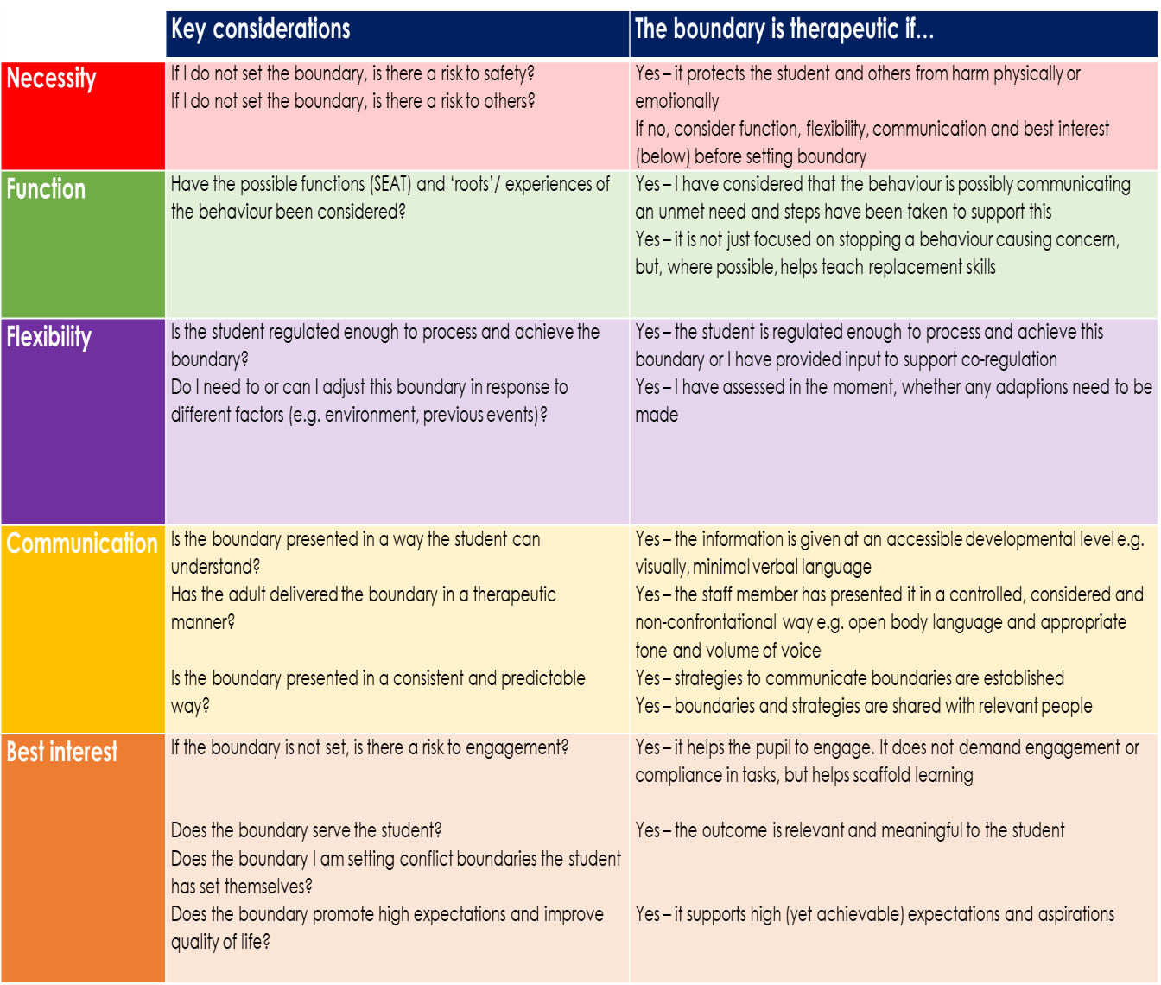

Educational and Protective Consequences
Educational consequences are in response to an educational need identified. These should not be done if they would cause negative or unsocial emotional responses for the student, for instance time would not be taken away from play or lunch times, or necessary support withheld. Educational consequences will be in line with the individual developmental stage.
Examples of this are;
- Time set aside with a specific member of staff to support in a particular way
- Referrals to additional support services
- Discussion with parents/carers
- Personalised workspaces or work stations
- Development of personalised timetables
- Additional time given for specific learning tasks
Protective Consequences are immediate and the aim will always be that no further harm is caused by antisocial behaviour. These will be proportionate and appropriate to the situation.
It is crucial that there is always an element of restorative practice. We must be able to show how we have helped the student develop new skills or ways of thinking through discussion, debriefing activity or rehearsing. Restorative practices support the student to gain the skills, appropriate to their developmental stage, to behave differently when faced with reoccurring circumstances.
Sometimes, a protective consequence is needed immediately and may remain in place until the risk of harm has been reduced and the student(s) remain safe. An example of this may be that a student is supported 1:1 for a particular activity and this may need to remain in place until it is no longer necessary. For example, for a short period of time a student’s break is at a different time than others to provide the appropriate environment and support. This is not a sanction this is a supportive action, a protective consequence in order to provide safety.
The Castle School follows the PROACT-SCIPr-UK® principles that are formed around the Positive Range of Options to Avoid Crisis and use Therapy Strategies for Crisis Intervention and Prevention. This approach is underpinned by good practice guidelines from the British Institute of Learning Disabilities (BILD) and the Restraint Reduction Network Training Standards 2019 (tbc). In extremely challenging circumstances, in order to prevent significant harm, it may be necessary to use physical intervention. Every step should be taken to avoid this, through practice centred on proactive and pre-emptive approaches and planning.
The Restrictive Interventions Policy states that at The Castle School we strive to create a safe, secure and supportive environment for all our pupils and staff. There are times when the use of restrictive interventions, including reasonable force and seclusion, is lawful and necessary to keep people safe. However, we understand that the use of restrictive interventions can have a significant impact on pupils, staff and parents/carers. In our school, they are only ever considered as a last resort, once all other prevention and de-escalation strategies have been exhausted.
In the occurrence of an incident resulting in physical restrictive intervention, it is essential that the Senior Leadership Team are informed, who will advise on further actions, including the potential monitoring of individuals involved. A full, open and transparent account of the incident must be recorded and submitted on Crest.
Although restraint can be used as a last resort and when ‘reasonable in the circumstances… with no more force than is needed’ (Department for Education, 2013, p.4), further action must then be taken to reduce the risk of similar instances from reoccurring. The communicative behaviour or response of the student to the scenario is now predictable and therefore a reliance on physical restrictive intervention as a primary strategy is not acceptable. Instead, staff teams will be supported to implement a support plan or strategies in line with Therapeutic Thinking and PROACT-SCIPr-UK®.
Through person centred planning and collaboration with the wider team around the student (SLT, Pastoral/ home, PROACT-SCIPr-UK®), the most suitable intervention will be established from the formally recognised interventions recommended by PROACT-SCIPr-UK®. These are then only taught to class teams working immediately with the individual, in conjunction with a Positive Behaviour Support/ Therapeutic Plan and accompanying risk assessment. Individual support plans are reviewed continuously (at least termly), alongside a Training Needs Analysis and Annual Physical Intervention Reduction Audit.
DfE. (2013). Use of reasonable force - Advice for headteachers, staff and governing bodies

Partnership with Parents/Carers
We work closely with our parents and carers, aiming for a consistent therapeutic approach. All individual plans and approaches are shared with parents/carers/other support providers and where appropriate, they are involved in the planning of therapeutic strategies for individual students.
Staff wellbeing
A therapeutic approach relates to all people within the school. The wellbeing of staff is of high importance. Following an incident of dysregulated, unsafe or behaviour that challenges, staff will be supported by the Senior Leadership Team through debrief. This may be a short conversation, it may be important to plan a time, shortly after the event to talk more fully. These approaches may look different, however, all have the same aim; to best support the individual/team.
Staff wellbeing is paramount and the ability to communicate and debrief with regards to behaviour that challenges is vital. Staff need to feel supported, valued and listened to in order for therapeutic approaches to flourish. The school is committed to the values of ‘done with - not done to’, through the ethos, environment, experiences and expertise of staff.
Bullying and Online Bullying
Students are encouraged to seek help and advice of adults to support them with any concerns around bullying. Students are encouraged to care for the well-being of themselves and their peers. Students are taught to report any concerns as soon as they happen, to allow situations to be addressed; allowing the revisit, reflect and repair process to occur through positive discussion before the situation escalates.
We deliver anti-bullying learning through internalisation of the schools aims and objectives, values and ethos via:
- Modelling pro-social behaviour
- Supporting and promoting our school values
- PHSE Lessons – discussion on topics of equal rights, relationships, reflection of own behaviour, impact of our actions on others (this is not an exhaustive list)
- Protective consequences where deemed necessary
- The broader taught curriculum

Any case of bullying or online bullying will not be tolerated and will be addressed on an individual basis and support will be given to all involved as deemed necessary. Parents of all involved will be informed.
Reports of bullying must be recorded and shared with SLT and an individualised approach will be applied and all actions shared with parents of all students involved. Immediate responses will aim to ensure sense of safety is restored swiftly and further actions agreed will be communicated to students and parents.
Protective consequences may include but are not limited to, students being supported 1:1, change of learning environment and structured restorative discussions.
Restorative work is carried out with the student focused around the impact upon others, what can be done to restore and repair and what is needed in order to prevent reoccurrence. This work is differentiated for the learning needs of the students and is appropriate to development stage.
Students will be supported to understand bullying, the impact of bullying and how to speak out to stay safe through class discussions and the PSHE curriculum.

Child On Child Abuse – Including Sexual Violence and Sexual Harassment
Part 5 of Keeping Children Safe In Education sets out statutory guidance on how schools should respond to all signs, reports and concerns of child-on-child sexual violence and sexual harassment, including those that have happened outside of school or college premises, and/or online (what to look our for and indicators of abuse are set out in Part 5 of Keeping Children Safe In Education).
All adults working with children are expected to maintain an attitude of ‘it could happen here’, and this is especially important when considering child-on-child abuse.
This element of the Behaviour Policy must be read alongside Keeping Children Safe In Education and the Castle School Child Protection and Safeguarding Policy. Reporting, recording and responding to incidents of child-on-child abuse will be managed in conjunction with this guidance and policy.
Behaviours that are considered as child-on-child abuse are set out in paragraph 35 of Keeping Children Safe in Education (KCSIE) .
Child-on-child abuse is most likely to include, but may not be limited to:
- bullying (including cyberbullying, prejudice-based and discriminatory bullying)
- abuse in intimate personal relationships between children (sometimes known as ‘teenage relationship abuse’)
- physical abuse such as hitting, kicking, shaking, biting, hair pulling, or otherwise causing physical harm (this may include an online element which facilitates, threatens and/or encourages physical abuse)
- sexual violence such as rape, assault by penetration and sexual assault; (this may include an online element which facilitates, threatens and/or encourages sexual violence)
- sexual harassment such as sexual comments, remarks, jokes and online sexual harassment, which may be standalone or part of a broader pattern of abuse
- causing someone to engage in sexual activity without consent, such as forcing someone to strip, touch themselves sexually, or to engage in sexual activity with a third party
- consensual and non-consensual sharing of nude and semi-nude images and/or videos (also known as sexting or youth produced sexual imagery)
- upskirting which typically involves taking a picture under a person’s clothing without their permission, with the intention of viewing their genitals or buttocks to obtain sexual gratification, or cause the victim humiliation, distress, or alarm, and
- initiation/hazing type violence and rituals (this could include activities involving harassment, abuse or humiliation used as a way of initiating a person into a group and may also include an online element).
Keeping Children Safe in Education (KCSIE) .

Any form of Child-On-Child Abuse will not be tolerated and must always be challenged. The response will be proportionate and will always reflect the needs of all students involved. The age and developmental stage of the alleged perpetrator(s) will always be considered when a response is planned. In all cases, the response and support plan will be devised on a case by case basis and will always involve a member of the Senior Leadership Team.
Support will always be given to the victim of abuse and their needs will be prioritised.
Low Level incidents are always more frequent than more severe incidents and must be challenged. Adults must listen to, take seriously and record all incidences of child-on-child abuse no matter how ‘low level’ on MyConcern.
In incidences of Sexual Violence or Sexual Harassment, the Brooks Harmful Sexualised Behaviour Tool may be used to support assessment of need.
Priority will be given to safety consequences in the first instance, such as individuals being taught in a different area of the school for a period of time. Educational consequences will then be planned with the team(s) working with all students involved.
In all cases, parents will be informed and asked to participate in the support planning, unless doing so places the student at risk.
In all cases, the response will follow the procedures set out in the Child Protection and Safeguarding Policy, all incidences and responses will be recorded through MyConcern.
In some cases, referrals to other agencies will be made. These may include, early help responses in school, Children’s Services, the Police or non-statutory agencies as appropriate. The decision making will follow The Child Protection and Safeguarding Policy and Keeping Children Safe In Education. In all cases of Sexual Violence and Sexual Harassment referrals to Children’s Services will always be made and consultation about police referral sought from them.

Mobile Phones and Mobile Technology In School
Mobile Phones In School
In February 2024, The Department for Education released guidance for all schools in relation to Mobile Phones. This guidance stated that ‘Every school has a duty to create an environment that is calm, safe and free from distraction so all pupils, whatever their background, can learn and thrive. One of the greatest challenges facing schools is the presence of mobile phones and the guidance states ‘schools should prohibit the use of mobile phones throughout the school day’.
The Castle School recognises the benefits mobile technology can bring to our students and the need to support students in developing understanding and skills of online safety especially relating to mobile technology. There must be balance with the need for students to experience calm, positive and safe learning environments.
The Castle School adopts the rule that students keep possession of their mobile phones only on the strict condition that they are not to be used, unless expressly agreed with school staff for educational or therapeutic purposes. These agreements will be individual and solely based around the needs of students.
If students do not adhere to this rule, they will be reminded of the expectation verbally or with use of visuals as appropriate. Where a phone is not put away after a reminder of the rule, and its presence presents a behavioural concern, disruption to others or safeguarding concern, parents will be contacted and asked to come to school to collect the phone. This consequence will be applied in consultation with the student’s Therapeutic Plan and will always aim to preserve the needs of all students.

School exclusions and suspensions
Suspensions may be required for the safety of student and adults, and to allow time for school staff to create a new plan to support the student. Suspensions will only happen in exceptional circumstances when remaining on school grounds would be considered unsafe for the student, other students or staff. This will be at the Headteacher’s discretion.
If it is necessary to suspend or exclude a student, West Berkshire Special Educational Needs Team will be informed. A full reintegration plan will be developed that will involve a review of the student’s Therapeutic Plan.
Permanent Exclusions could occur when the Headteacher reaches the conclusion that a student should not return to school due to severity of risk posed by a students’ behaviour. This action is typically taken as a very last resort in line with the School Exclusion Policy.
Responsibilities, Monitoring and Evaluation

All Staff
- Will be positive role models
- Will apply this policy in conjunction with the Code of Conduct and Child Protection and Safeguarding Policy
- Apply recommended strategies, language, approaches and scripts to ensure equity for all
- All staff are responsible for the timely recording and reporting of unsocial behaviours and antisocial behaviours through ABC recording systems, CREST (for incidents and accidents) and MyConcern.

Information recorded through these methods are reviewed by SLT and used to inform educational and safety consequences, review and inform individual
Therapeutic Plans. Review of Therapeutic Plans will be a minimum of twice a year

The Headteacher will
- Implement the school’s Behaviour Policy within the school
- Ensure that training is up to date and reflective of current therapeutic practices
- Model therapeutic practices and language in all that they do
- Ensure that all staff model therapeutic practices in all that they do
- Promote internal-discipline and self-regulation amongst all members of the school community
- Encourage positive behaviour and respect for others
- Regulate therapeutic practices through effective observation, reporting and monitoring systems
- Review the impact of therapeutic approaches on progress, attendance and exclusions each term.
- Address behaviour considered to be ‘dangerous’ in a prompt and transparent manner, in order to provide protection to all members of the school community

Governors will
- Support the Headteacher and senior leaders to review and redevelop school policies to align with the school’s therapeutic approach
- Model therapeutic practices in all that they do
- Monitor, review and evaluate the Behaviour Policy through annual reports to the appropriate committee
- Monitor data on exclusions by protected characteristics through termly reports to the appropriate committee
- Conduct climate check visits to understand the therapeutic culture of the school

Appendices
- Behaviour Policy Flow Chart
- Therapeutic Tree
- Therapeutic Plan Template
- Scripted Language
- S.E.A.T – Functions of Behaviour

