Dear all,

Summer provision at Waterside Centre, Newbury and Thatcham

We’re pleased to be offering the free Holiday Activities and Food (HAF) programme funded by the Department for Education.
Launched earlier this year in West Berkshire, HAF is for children aged 4 to 16 who are in a full-time school place and receive Free School Meals. We are providing opportunities for young people aged 11+ in Thatcham and Newbury this Summer.

Young people will access community-based activities over the holidays and enjoy a range of fun activities while learning about nutrition and wellbeing.
As well as enjoying lots of enriching activities, they have a free, nutritious meal as part of the programme. We have sourced additional funding to make this opportunity open to all young people aged 11+, regardless of their situation, so young people can stay connected to their friends over the summer, with young people accessing the same opportunities in the same way, regardless of their FSM status.

We will prioritise spaces to those young people eligible for Free School Meals, so if you would like to reserve a space for your students or parents would for their child/children please complete the form and return to us.

The attached programme at Waterside Centre, Newbury will offer young people the first opportunity to access the recently refurbished centre, offering a range of activities and paddlesports.
In Thatcham we are working with community partners to create a range of opportunities across Thatcham.

After the last 18months I am sure you will agree, young people deserve to have some fun with their friends and we hope these offers will provide safe space for them this Summer.

Kind regards

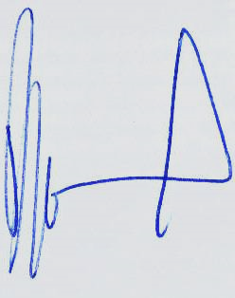

David Seward
Chief Executive

<<Primary Headteachers>>
<<Secondary Headteachers>>

16th July 2021

