

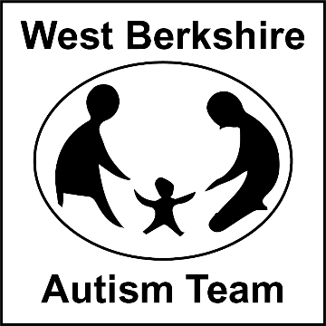
The Autism Team are having an Emotional Regulation Week (Commencing 24th May), where we will be running workshops for parents and schools, with advice sheets being emailed out in the same week. Please see below the events we are running for parents and professionals.
Emotional Regulation Week.
24th May to 28th May

25th May 2021 – Understanding and Supporting Self-Regulation Skills in Young People
Time: 7pm to 8.30pm
Venue: Zoom
Audience: Professionals and Parents

27th May 2021 – Understanding and Supporting Self–Regulation Skills in Young People

Time: 9.45am to 12noon
Venue: Zoom
Audience: Parents

Please contact Admin to book a place on: 01635 503646
Or email Learning Support Team
LearningSupportTeam@westberks.gov.uk

27th May 2021 – Understanding and Supporting Self–Regulation Skills in Young People
Time: 1.30-3pm
Venue: Zoom
Audience: Professionals

To book a place, please contact West Berkshire Training on:
Email: Training@westberks.gov.uk

Contact Details:
The Autism Team 01635 503652 or
learningsupportteam@westberks.gov.uk

